**Key differences between public and private IP addresses**

The main difference between public and private IP addresses is how far they reach, and what they’re connected to. A **public IP address** identifies you to the wider internet so that all the information you’re searching for can find you. A **private IP address** is used within a private network to connect securely to other devices within that same network.

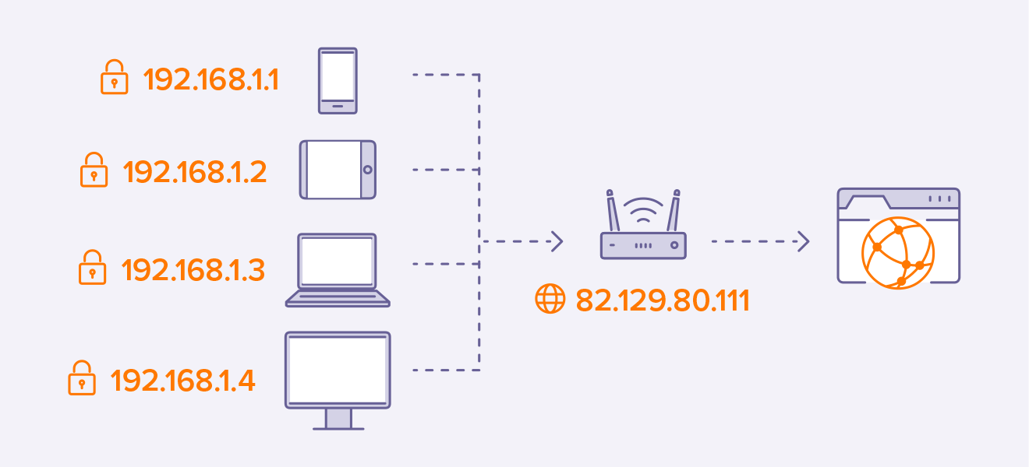

### Public and private IP address ranges

Your private IP address exists within specific private IP address ranges reserved by the Internet Assigned Numbers Authority (IANA) and should never appear on the internet. There are millions of private networks across the globe, all of which include devices assigned private IP addresses within these ranges:

* Class A: 10.0.0.0 — 10.255.255.255
* Class B: 172.16.0.0 — 172.31.255.255
* Class C: 192.168.0.0 — 192.168.255.255

These might not seem like wide ranges, but they don’t really need to be. Because these IP addresses are reserved for private network use only, they can be **reused on different private networks** all over the world — without consequence or confusion.

And don’t be surprised if you have a device or two at home with a so-called 192 IP address, or a private IP address beginning with **192.168**. This is the most common default private IP address format assigned to network routers around the globe.

Unsurprisingly, the public IP address range encompasses every number not reserved for the private IP range. Since a public IP address is a unique identifier for each device connected to the internet, it needs to be just that: unique.

### Summarizing the differences between private and public IP addresses

|  |  |
| --- | --- |
| **Public IP address** | **Private IP address** |
| External (global) reach | Internal (local) reach |
| Used for communicating outside your private network, over the internet | Used for communicating within your private network, with other devices in your home or office |
| A unique numeric code never reused by other devices | A non-unique numeric code that may be reused by other devices in other private networks |
| Found by Googling: "What is my IP address?" | Found via your device’s internal settings |
| Assigned and controlled by your internet service provider | Assigned to your specific device within a private network |
| Not free | Free |
| Any number not included in the reserved private IP address range  Example: 9.8.8.8. | 10.0.0.0 — 10.255.255.255; 172.16.0.0 — 172.31.255.255;  192.168.0.0 — 192.168.255.255  Example: 10.11.12.13 |